EKS labs

Log in to the Amazon management console, open EC2 Dashboard, click on the Launch Instance drop-down list, and click on Launch Instance as shown below:

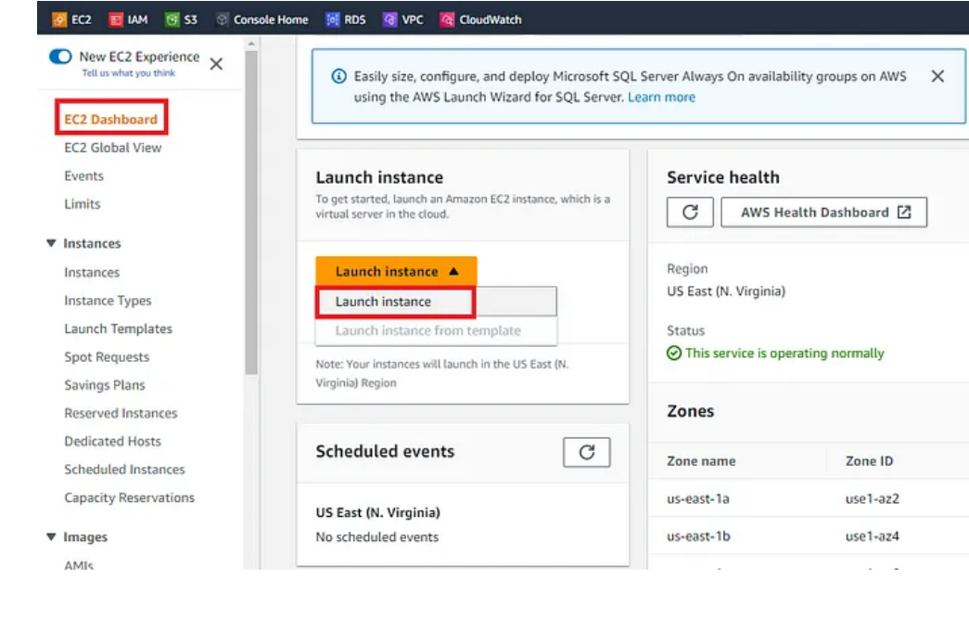

Once the **Launch an instance** window opens, provide the name of your EC2 Instance:

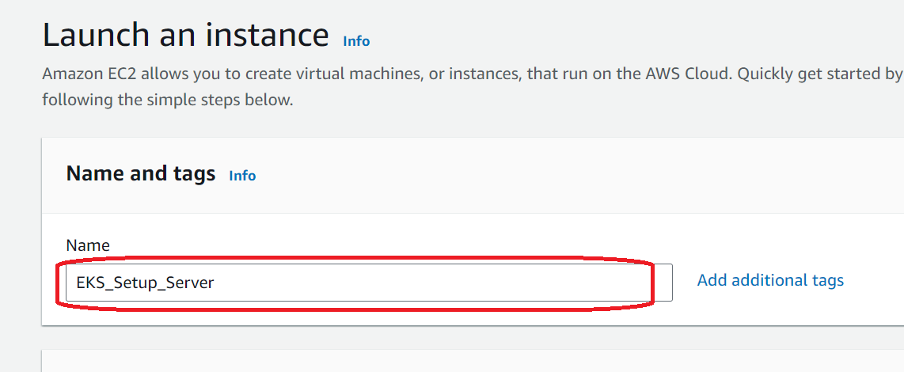

For this demo, we will select Amazon Linux 2 AMI which is free tier eligible.

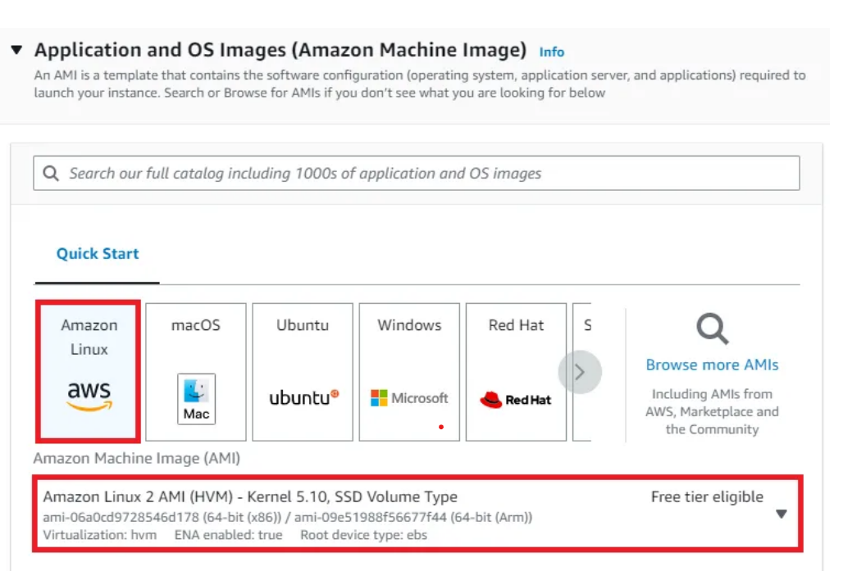

Choose an Instance Type. Here you can select the type of machine, number of vCPUs, and memory that you want to have. Select **t2.micro** which is free-tier eligible.

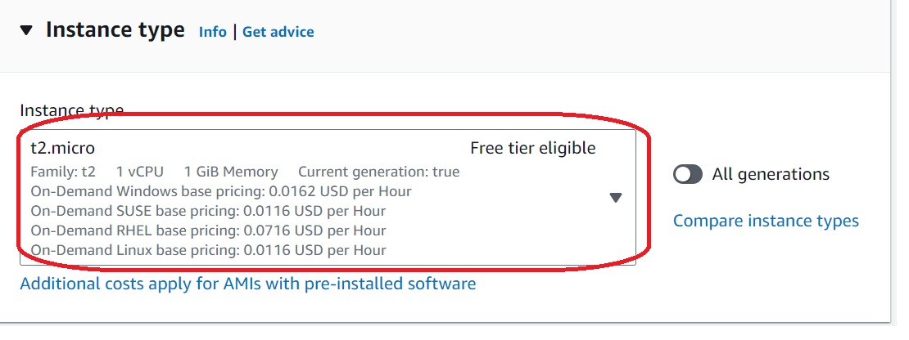

Create new Keypair

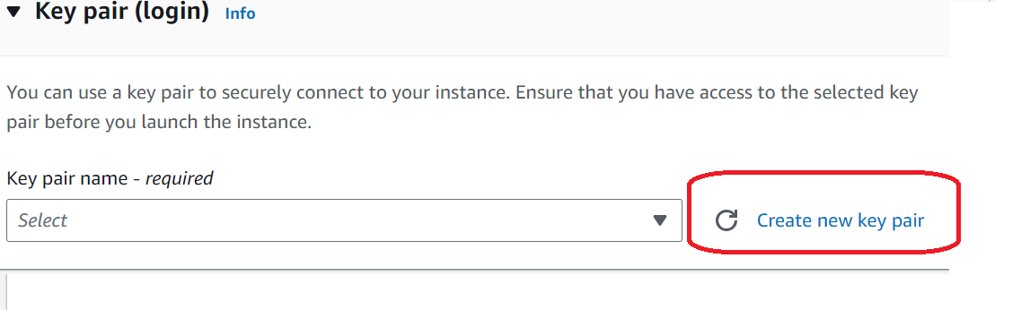

Key pair (creating for putty)

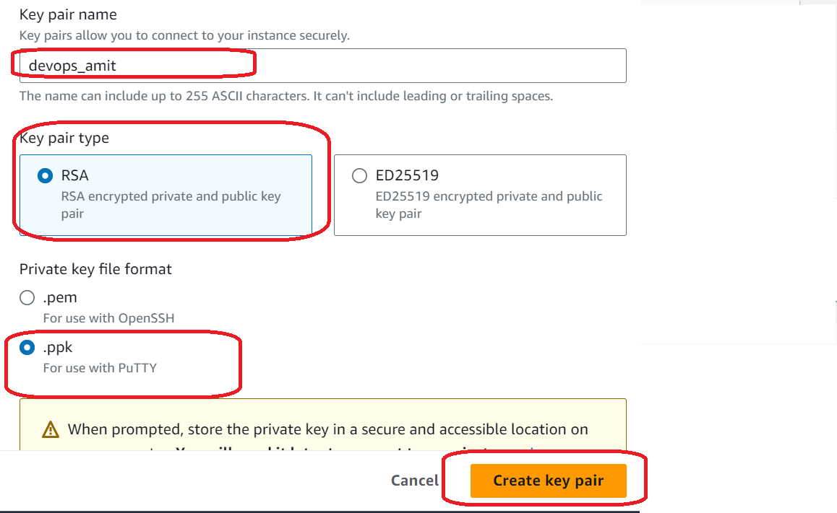

Note: It will download one ppk file

Go to network settings edit option and

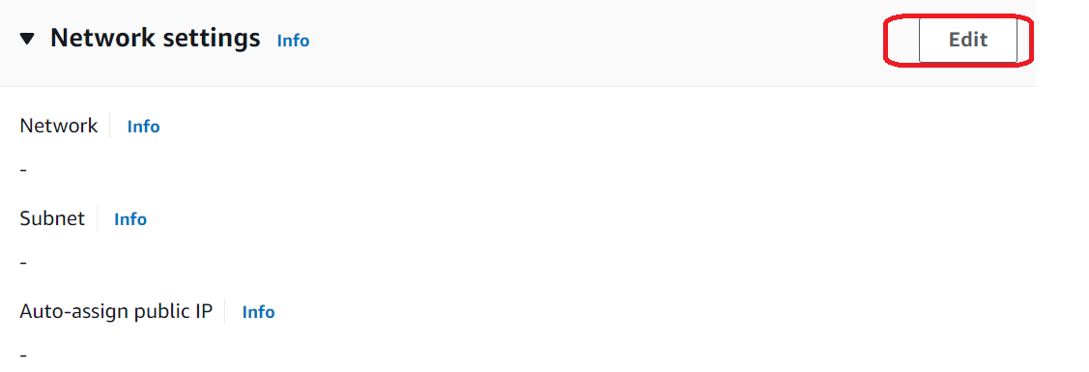

Select VPC, subnet and make auto-assign public ip enable

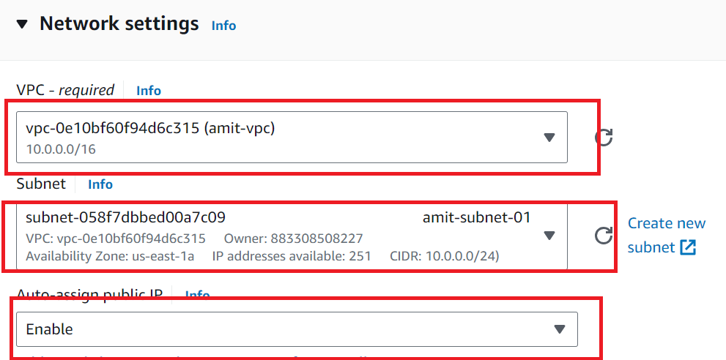

Create a Security group

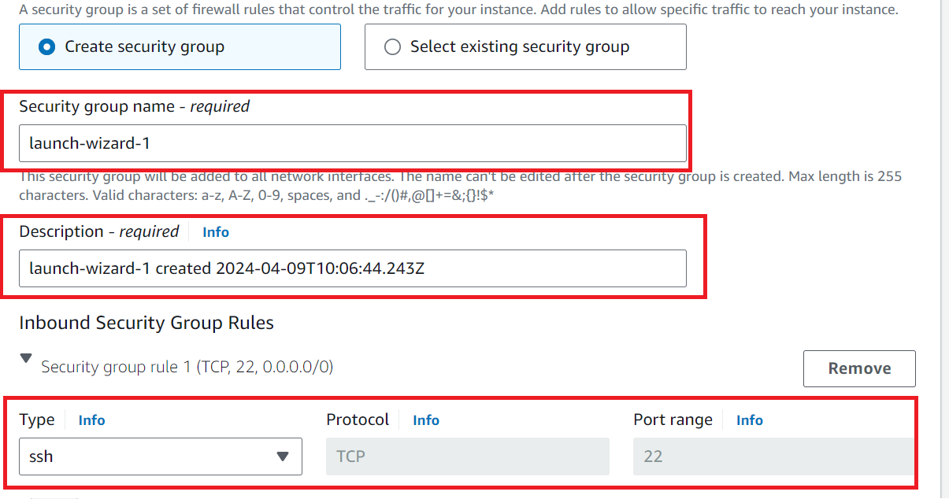

Rest of the settings we will keep them at default and go ahead and click on **Launch Instance**

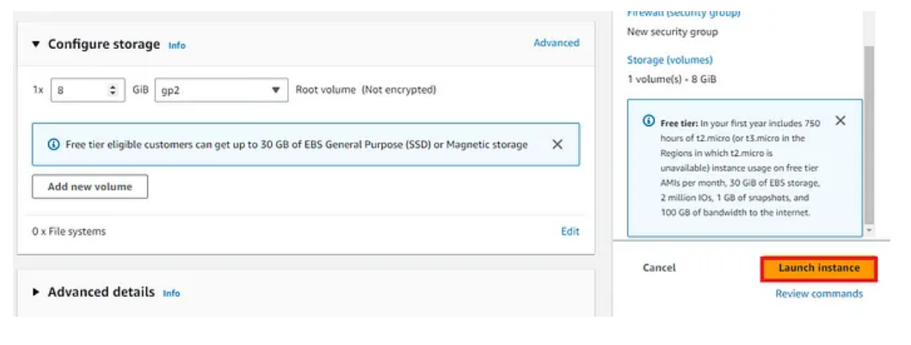

On the next screen you can see a success message after the successful creation of the EC2 instance, click on **Connect to instance** button:

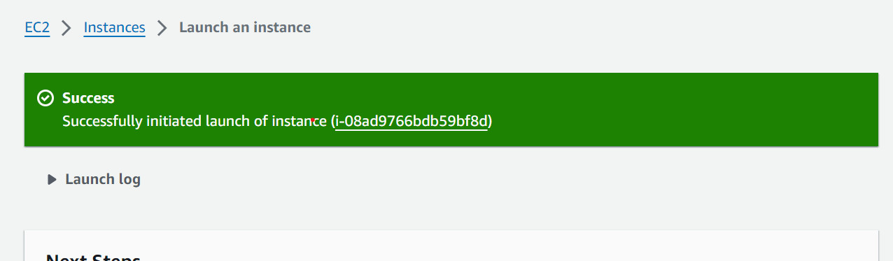

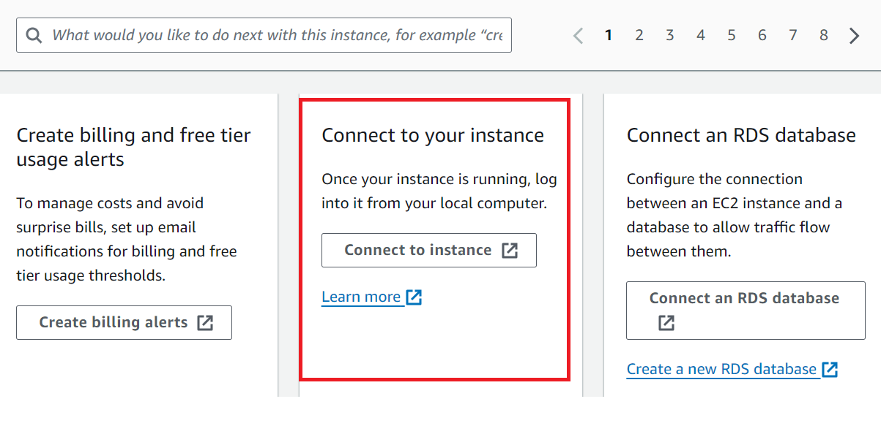

Noted Down the ip address and user name

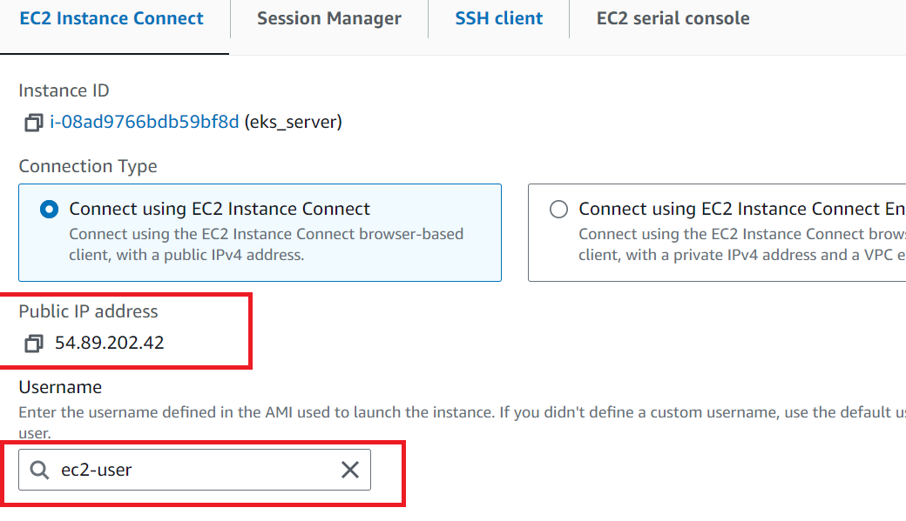

Download Putty from putty.org

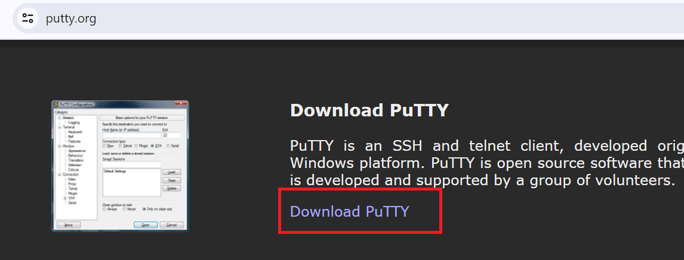

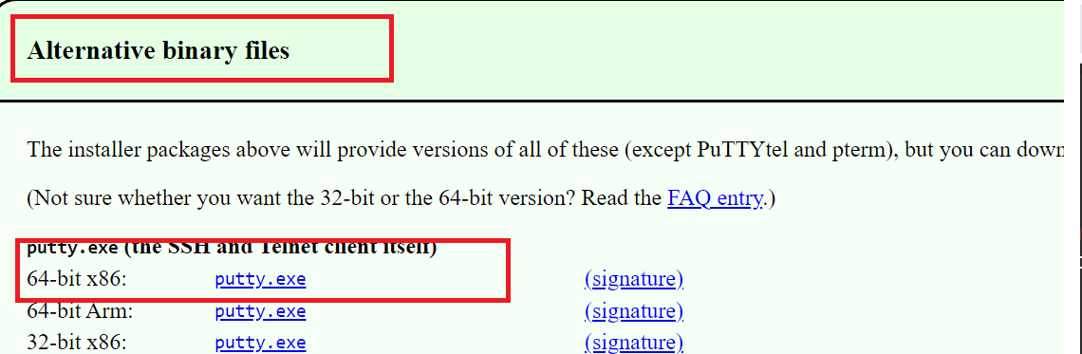

Open putty.exe and provide details ec2-user@<public ip>

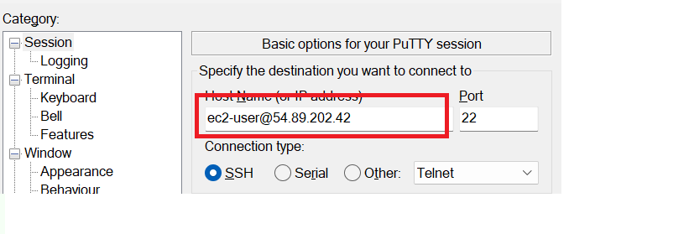

Go to putty Auth ->Credentials session

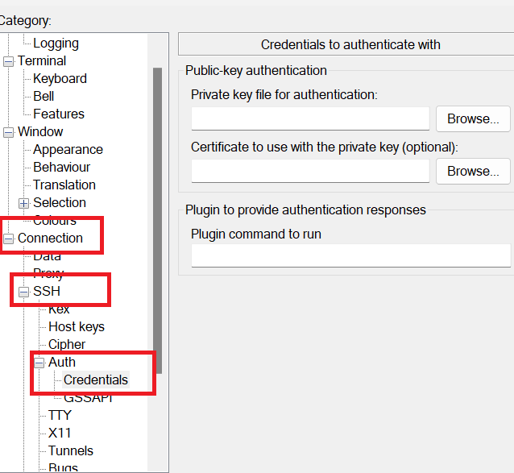

**Browse and Map the ppk file which we generated in key-pair section**

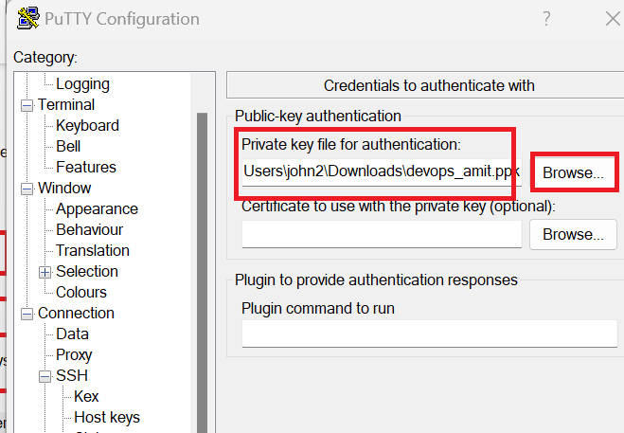

Click on Open

